LAB 6
NAME: Hajra Sarwar REG NO: 2023-BSE-022
CLASS: BSE-5A
SUBJECT: CC

LAB TITLE: Linux Users, Groups, Permissions, Pipes, and Bash Scripting

TASK:

Task 1: Switch to root with su – and back to a normal user
Goal:
Demonstrate switching to the root account using su – and then returning to the normal user.
Steps Performed:
- Set a root password (Ubuntu root is disabled by default; this step enables su – temporarily for the lab):
sudo passwd root
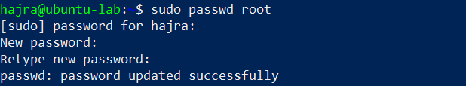
  - Entered a temporary root password for this lab.
- Switch to the root user and verify:
su –
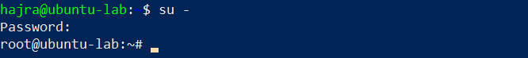
Whoami
Id
  - Confirmed that the current user is root.
- Switch back to the normal user and verify:
Exit
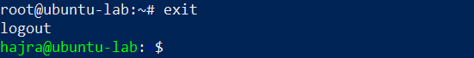
Whoami
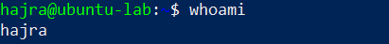
  - Returned to the normal user successfully.

Task 2: Create user tom and verify in passwd/group/shadow
Goal:
Create a user named tom, then verify the account details in the system files.
Steps Performed:
- Create a new user tom (interactive command that sets a password and creates a home directory):
sudo adduser tom
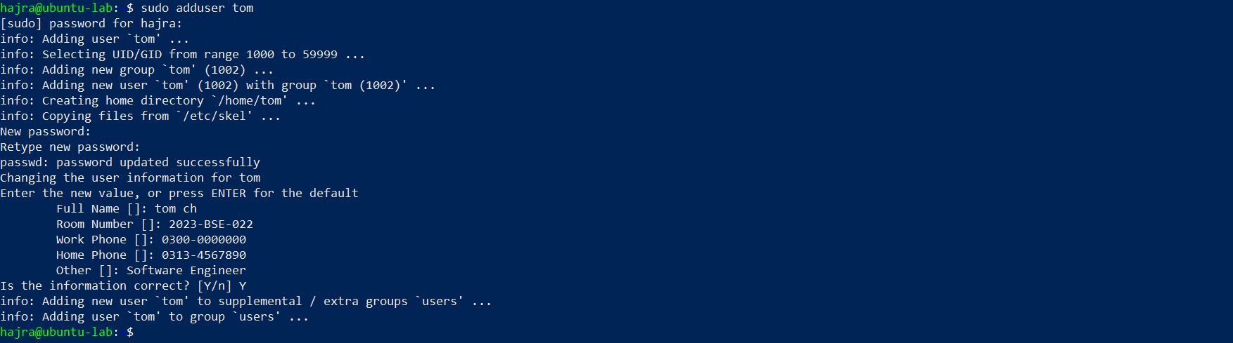
  - Entered password and user information as prompted.
- Verify user tom in the /etc/passwd file:
cat /etc/passwd
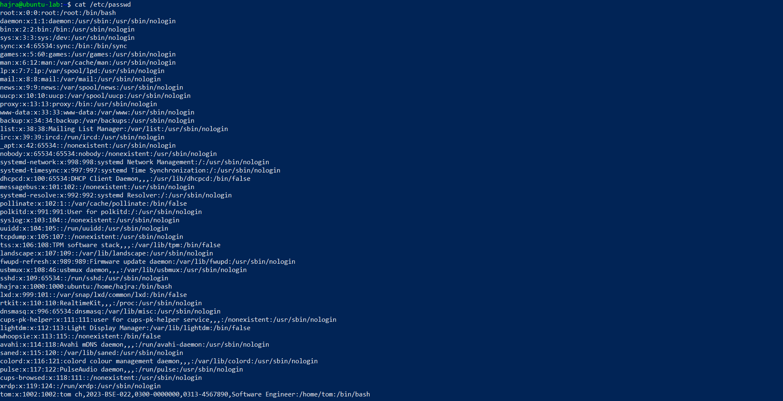
  - Confirmed that a new entry for tom exists, indicating the user account and home directory.
- Verify user tom in the /etc/group file:
cat /etc/group
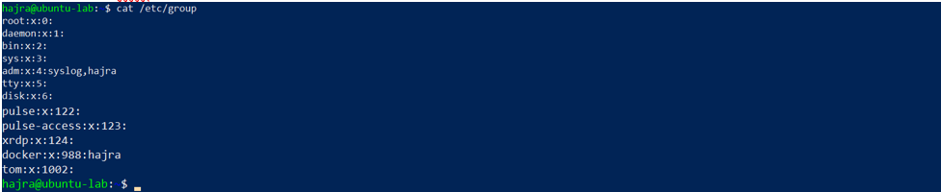
  - Verified that tom is listed in the appropriate user group.
- Verify user tom in the /etc/shadow file:
sudo cat /etc/shadow
  - Confirmed that tom has an entry with a hashed password (not visible in plaintext).

Task 3: Create groups; change tom’s primary and secondary groups
Goal:
Create groups developer, devops, and designer. Then change tom’s primary group and manage secondary group memberships.
Steps Performed:
- Create the required groups and verify:
sudo groupadd developer
sudo groupadd devops
sudo groupadd designer
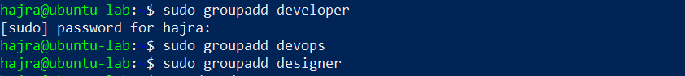
cat /etc/group
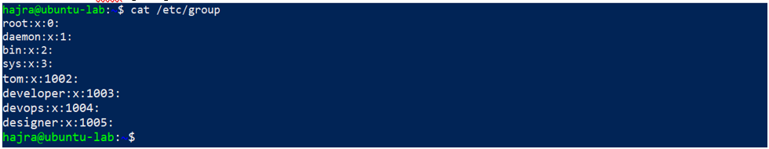
  - Verified that the new groups developer, devops, and designer were successfully added in /etc/group.
- Change tom’s primary group to designer and verify:
sudo usermod -g designer tom
id tom
  - Confirmed that designer is now set as tom’s primary group.
- Add secondary groups developer and devops to tom and verify:
sudo usermod -aG developer,devops tom
id tom
groups tom
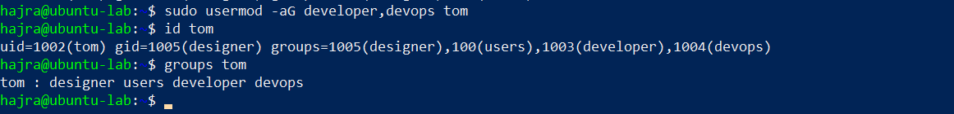
  - Verified that tom now belongs to the developer and devops groups as secondary groups.
- Reset secondary groups so only tom (user’s own group) remains and verify:
sudo usermod -G tom tom
id tom
groups tom
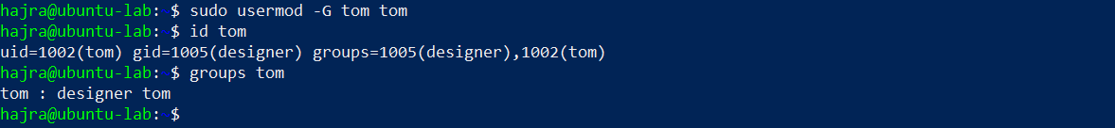
  - Confirmed that all additional secondary groups were removed, leaving only tom’s default group.

Task 4: Create/Delete Users (Jerry, Scooby) and Groups (jolly, anime)
Goal:
Create users using both adduser and useradd, demonstrate login, password, and home directory differences, then delete the created users and groups.

Steps Performed:
- Create new users Jerry and Scooby:
sudo adduser Jerry
sudo useradd Scooby
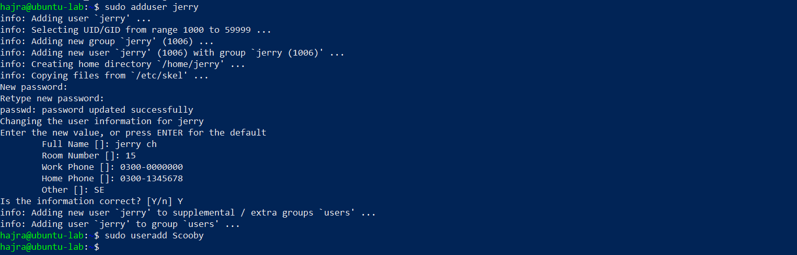
  - adduser automatically created a home directory and prompted for a password.
  - useradd created a basic user account without a home directory or password.
- Attempt to log in as Scooby before setting a password (expected failure):
su – Scooby
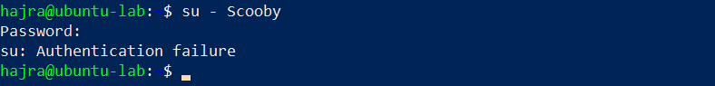
  - Authentication failed because Scooby had no password.
- Set a password for Scooby:
sudo passwd Scooby
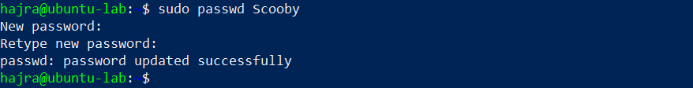
  - Assigned a password successfully.
- Log in again as Scooby (observe missing home directory warning):
su – Scooby
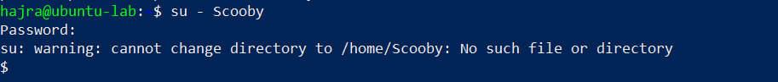
  - System displayed: “No directory, logging in with HOME=/”.
- Verify Scooby’s home directory and /etc/passwd entry:
Exit
cat /etc/passwd
ls -ld /home/Scooby
  - Confirmed that /home/Scooby did not exist.

- Manually create Scooby’s home directory and set ownership/permissions:
sudo mkdir -p /home/Scooby
sudo chown Scooby:Scooby /home/Scooby
sudo chmod 750 /home/Scooby
ls -ld /home/Scooby
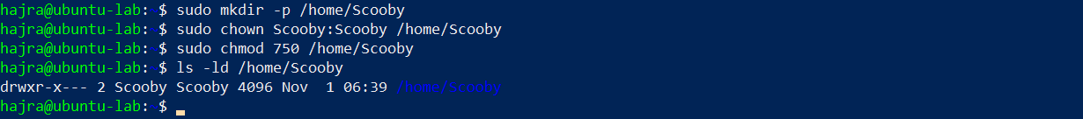
  - Successfully created and secured the directory.
- Log in as Scooby again to confirm correct home directory access:
su - Scooby
pwd
ls -la
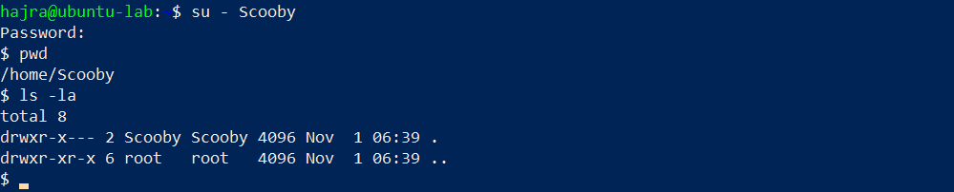
  - Verified proper login into /home/Scooby.
- Verify users in /etc/passwd and check Scooby’s shell:
exit
cat /etc/passwd
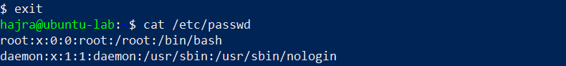
  - Observed Scooby’s shell set to /bin/sh.
- Change Scooby’s shell from /bin/sh to /bin/bash and verify:
sudo usermod -s /bin/bash Scooby
su – Scooby
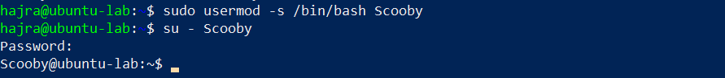
  - Verified new default shell as /bin/bash.
- Create groups jolly and anime:
sudo addgroup jolly
sudo groupadd anime
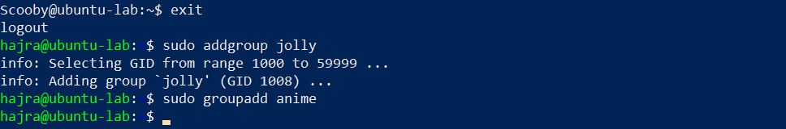
- Verify groups in /etc/group:
cat /etc/group
  - Confirmed successful creation of both groups.
- Delete the groups and users:
sudo delgroup jolly
sudo groupdel anime
cat /etc/group
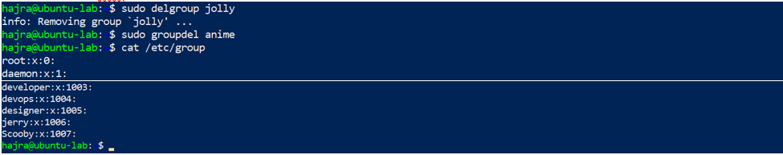
sudo deluser --remove-home Jerry
sudo userdel -r Scooby
cat /etc/passwd
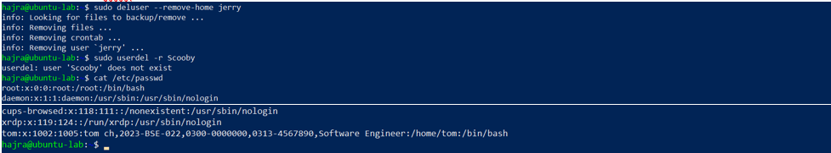
  - Verified that both users and groups were completely removed.

Task 5: Create User “Student”; Create Files; Set Owner/Group; Identify File Types
Goal:
Create a new user named Student, create files and directories, change ownership and group, and identify different file types including system special files.

Steps Performed:
- Create a new user Student:
sudo adduser Student
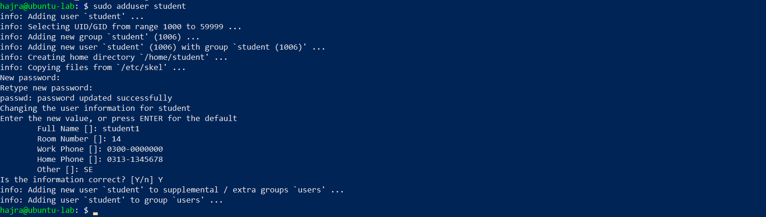
  - Entered a password and completed the setup for the Student user.
- Switch to Student and create files and directories:
su - Student
touch file1
mkdir -p dir1
touch dir1/file2
ls -l
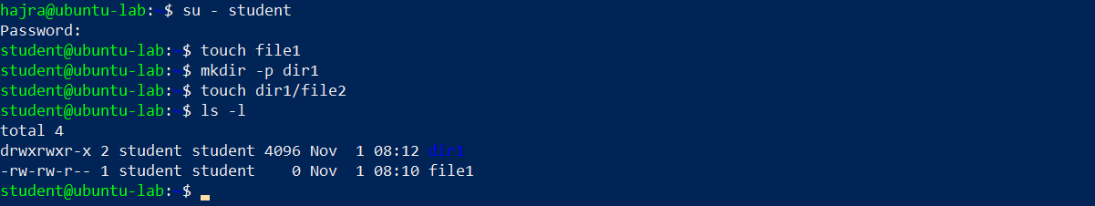
  - Created a file file1, a directory dir1, and a second file file2 inside it.
- Change the owner of file1 to tom and verify:
sudo chown tom file1
ls -l file1
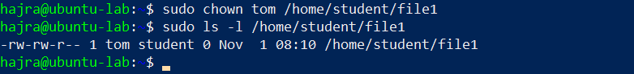
  - Confirmed that the file owner was updated to tom.
- Change the group of file1 to devops and verify:
sudo chgrp devops file1
ls -l file1
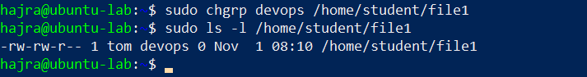
  - Verified that the file’s group ownership changed to devops.
- Identify files, directories, and special files:
ls -l
ls -l dir1
ls -l /dev/null
file file1 dir1 /dev/null
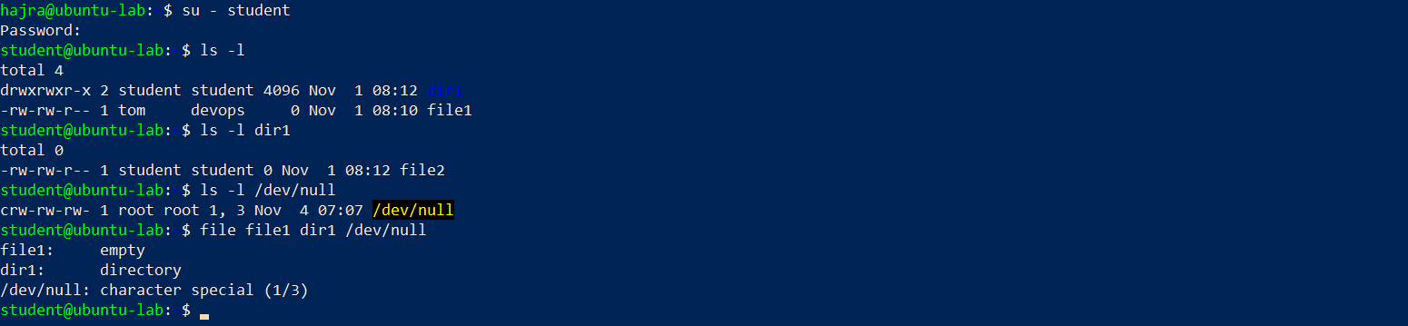
  - Observed file types:
    - file1 → regular file
    - dir1 → directory
    - /dev/null → special device file
- Exit from Student account:
Exit
  - Returned to the previous user successfully.

Task 6: Change Permissions Using Symbolic Mode
Goal:
Modify file permissions for ~/file1 using symbolic notation (r, w, x, u, g, o, and a) to demonstrate adding and removing different access levels.

Steps Performed:
- Ensure the Student user and target file exist:
su - Student
cd ~
ls -l file1
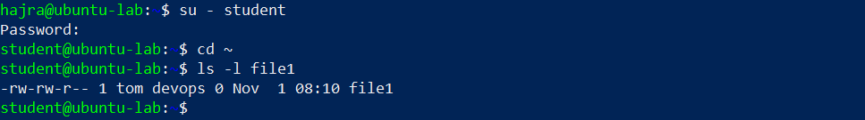
  - Confirmed presence of file1 in the home directory.
- Remove all permissions from file1:
chmod -rwx file1
ls -l file1
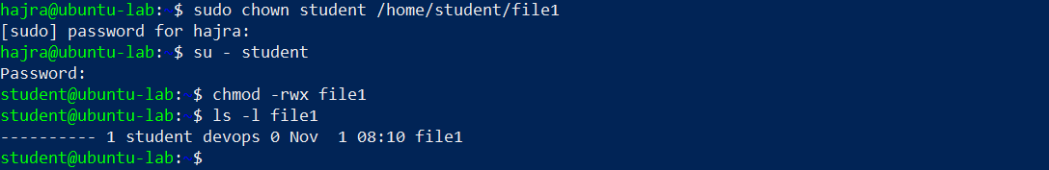
  - Verified that all permissions were removed (----------).
- Add read permission to all users:
chmod +r file1
ls -l file1
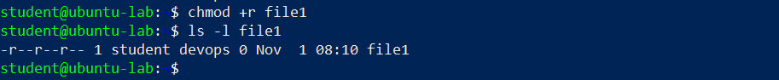
  - Confirmed that the file now has read (r) permission for user, group, and others.
- Add execute permission to the user (owner):
chmod u+x file1
ls -l file1
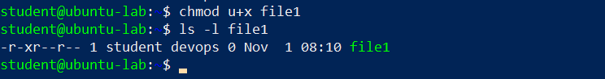
  - Verified that the user now has execute (x) permission.
- Add write permission to both user and group:
chmod ug+w file1
ls -l file1
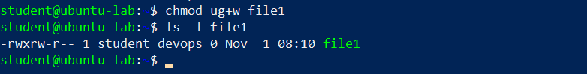
  - Confirmed that both user and group gained write (w) permission.
- Remove all permissions explicitly from user, group, and others:
chmod ugo-rwx file1
ls -l file1
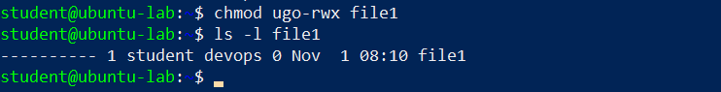
  - Verified that no permissions remain (----------).

Task 7: Change Permissions Using “Set” Symbolic Form (u= g= o=)
Goal:
Use the “set” symbolic form (u=, g=, o=) to assign and remove specific file permissions for the user, group, and others.

Steps Performed:
- Ensure you are logged in as Student and confirm the file exists:
su - Student
cd ~
ls -l file1
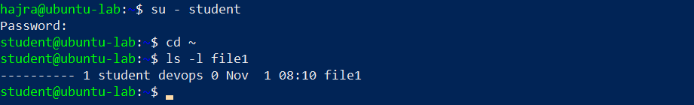
  - Verified that the current user is Student and the target file file1 exists in the home directory.
- Set all permissions (read, write, execute) for user, group, and others:
chmod u=rwx,g=rwx,o=rwx file1
ls -l file1
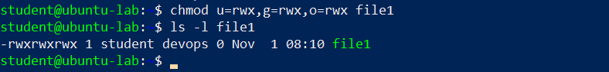
  - Confirmed that all permissions (rwxrwxrwx) were applied to the file.
- Remove execute permission from group and others:
chmod g=rw,o=rw file1
ls -l file1
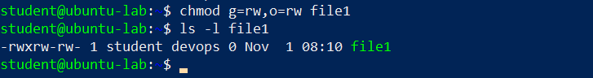
  - Verified that execute permission (x) was removed for both group and others, leaving (rwxrw-rw-).
- Remove all permissions from user, group, and others:
chmod u=,g=,o= file1
ls -l file1
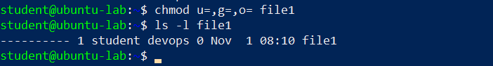
  - Confirmed that no permissions remain (----------).

Task 8: Change Permissions Using Numeric (Octal) Mode
Goal:
Demonstrate how to modify file permissions using numeric (octal) values to represent different combinations of read (r), write (w), and execute (x) permissions.

Steps Performed:
- Ensure you are logged in as Student and the file exists:
su - Student
cd ~
ls -l file1
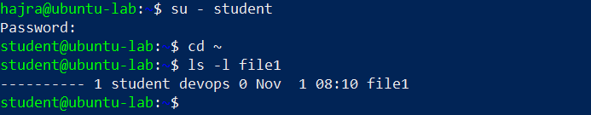
  - Verified that the current user is Student and file1 exists in the home directory.
- Set permissions to 777 (rwx for user, group, and others):
chmod 777 file1
ls -l file1
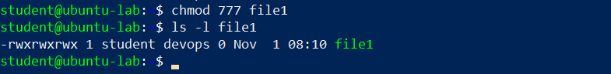
  - Verified full permissions: rwxrwxrwx
- Set permissions to 700 (rwx for user only):
chmod 700 file1
ls -l file1
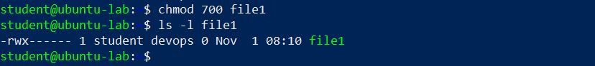
  - Verified permissions: rwx------
- Set permissions to 744 (rwx for user, read for group and others):
chmod 744 file1
ls -l file1
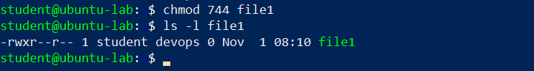
  - Verified permissions: rwxr--r--
- Set permissions to 640 (rw for user, r for group, none for others):
chmod 640 file1
ls -l file1
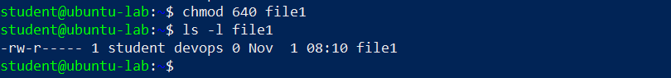
  - Verified permissions: rw-r-----
- Set permissions to 664 (rw for user and group, read for others):
chmod 664 file1
ls -l file1
  - Verified permissions: rw-rw-r--
- Set permissions to 775 (rwx for user and group, read/execute for others):
chmod 775 file1
ls -l file1
  - Verified permissions: rwxrwxr-x
- Set permissions to 750 (rwx for user, read/execute for group, none for others):
chmod 750 file1
ls -l file1
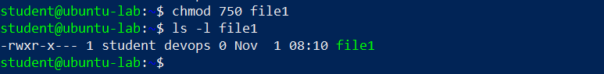
  - Verified permissions: rwxr-x---

Task 9: Practice Pipes, Pagers, Grep, and Redirects with /var/log/syslog
Goal:
Use Linux commands involving pipes (|), pagers (less, more), filters (grep), and redirects (>, >>) to explore and manipulate system log data from /var/log/syslog.

Steps Performed:
- View /var/log/syslog using less (with pipe):
sudo cat /var/log/syslog | less
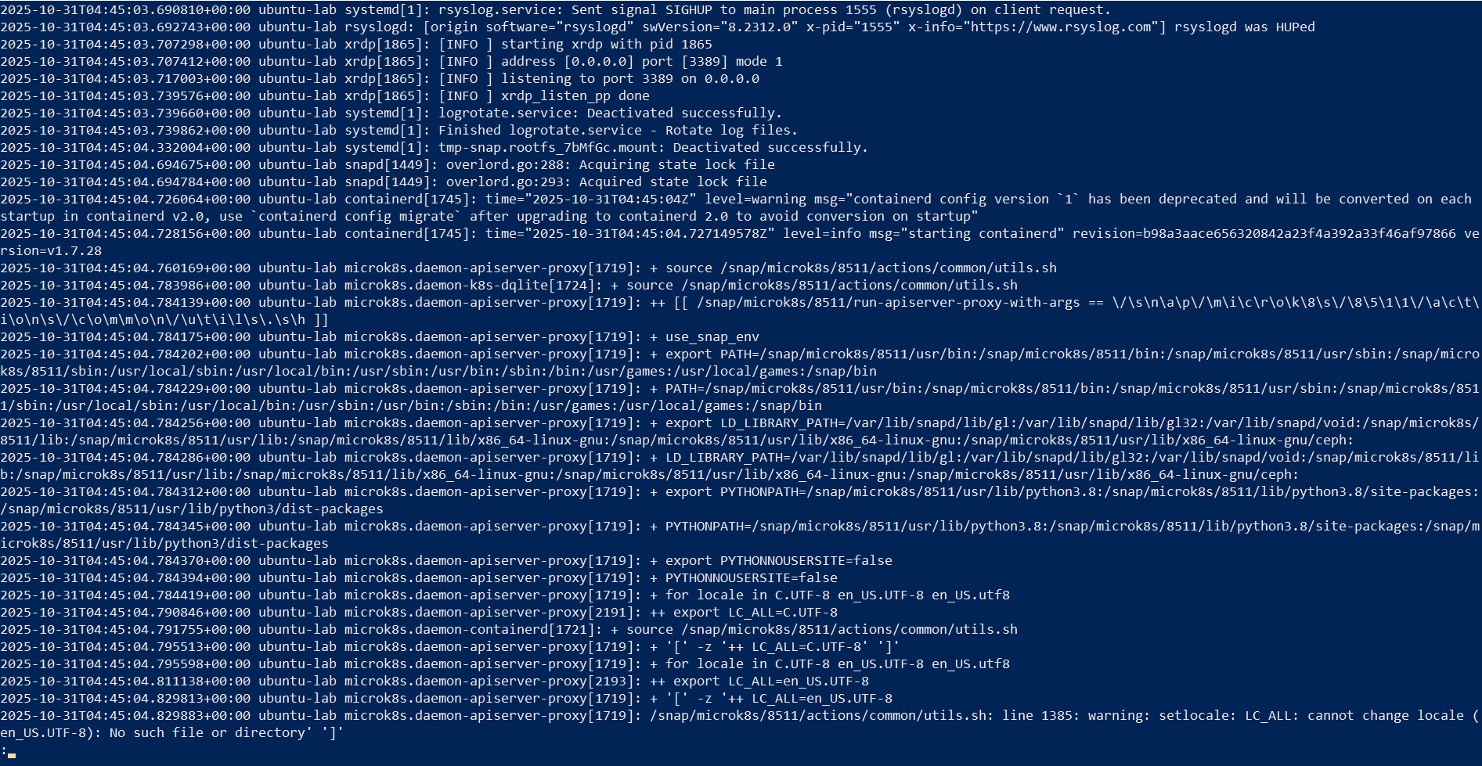
  - Used less as a pager to scroll through log content.
  - Exited using q.
- View /var/log/syslog using more (with pipe):
sudo cat /var/log/syslog | more
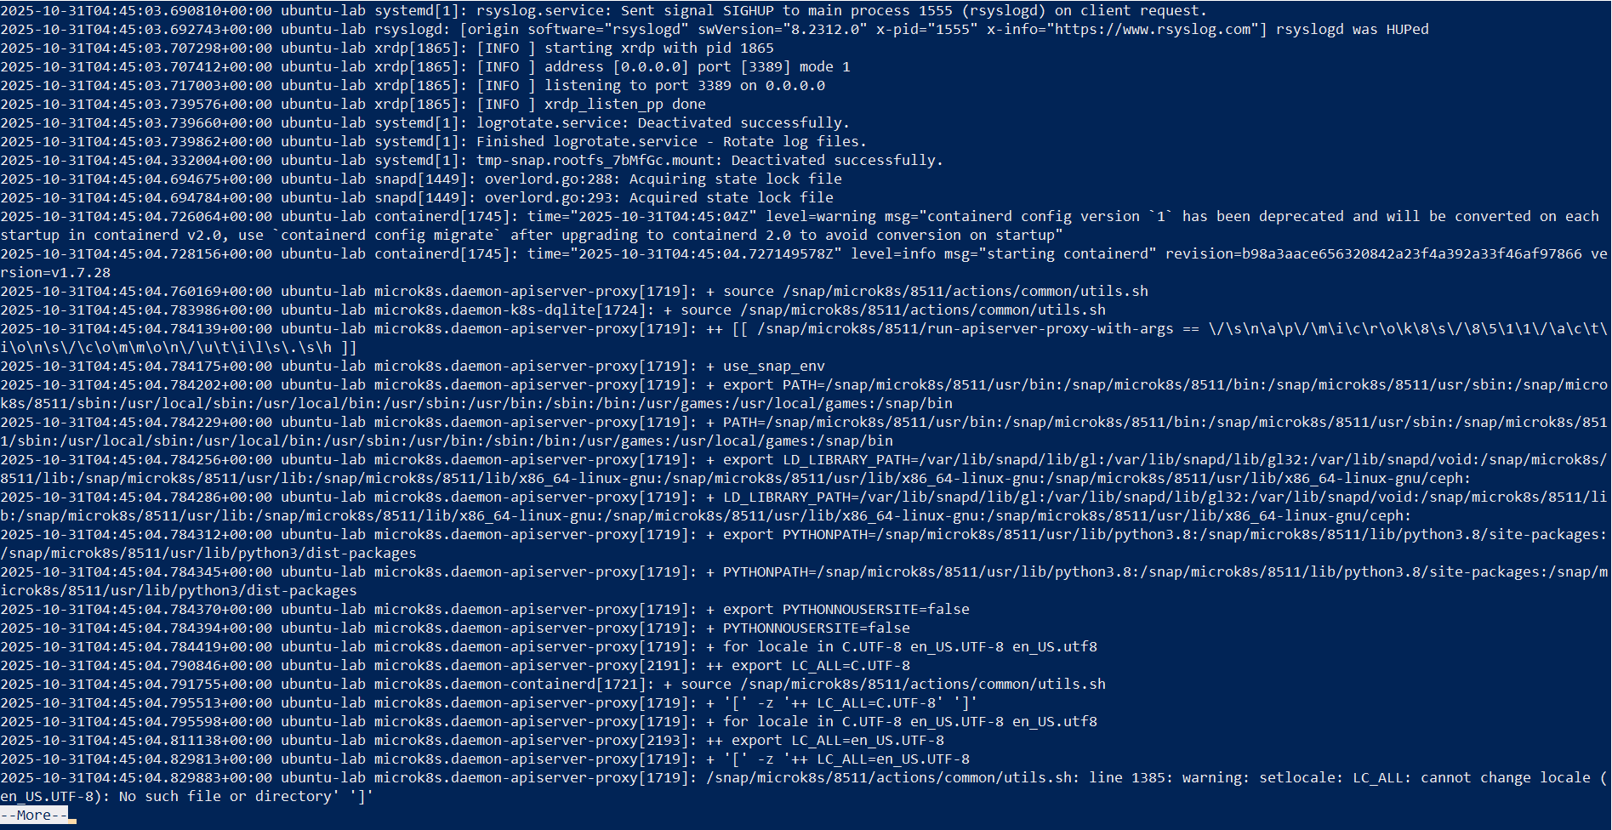
  - Displayed log file content page by page.
- Search for log entries containing “fail” or “error”:
sudo grep -E 'fail|error' /var/log/syslog | head
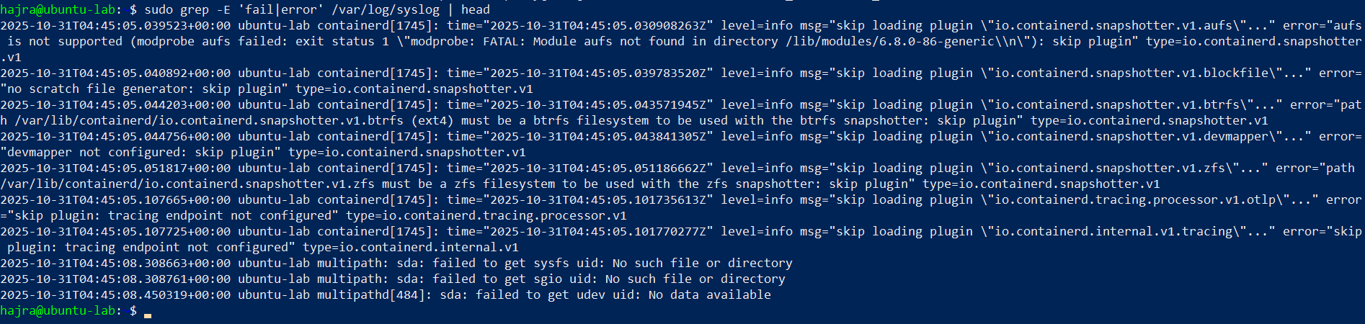
  - Displayed the first few lines that matched either “fail” or “error.”
- Redirect search results to a new file (overwrite mode):
sudo grep -i systemd /var/log/syslog > ~/syslog_systemd.txt
  - Created (or replaced) a file named syslog_systemd.txt containing all “systemd” log entries.
- Append additional search results to the same file:
sudo grep -i network /var/log/syslog >> ~/syslog_systemd.txt
cat ~/syslog_systemd.txt
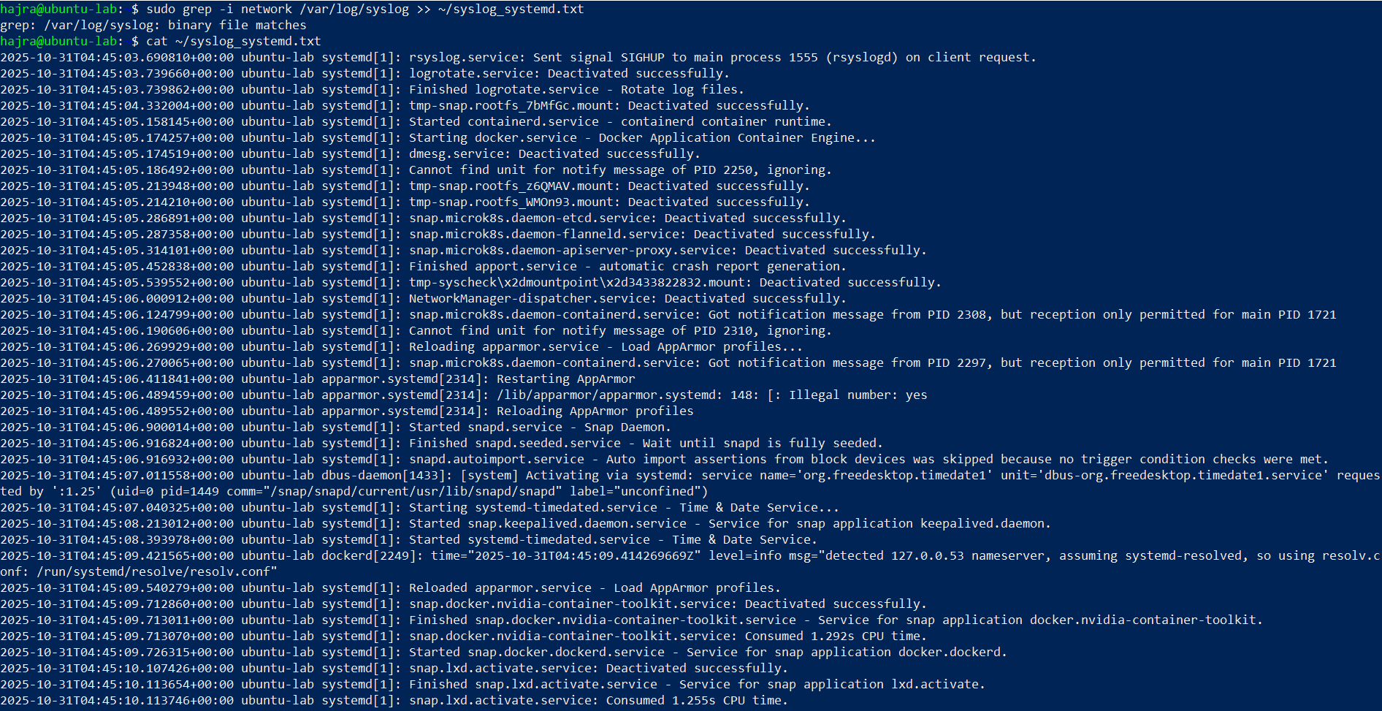
  - Appended “network”-related entries to the same text file and verified the combined output.
- (Alternative) Use journalctl to explore logs:
sudo journalctl | less
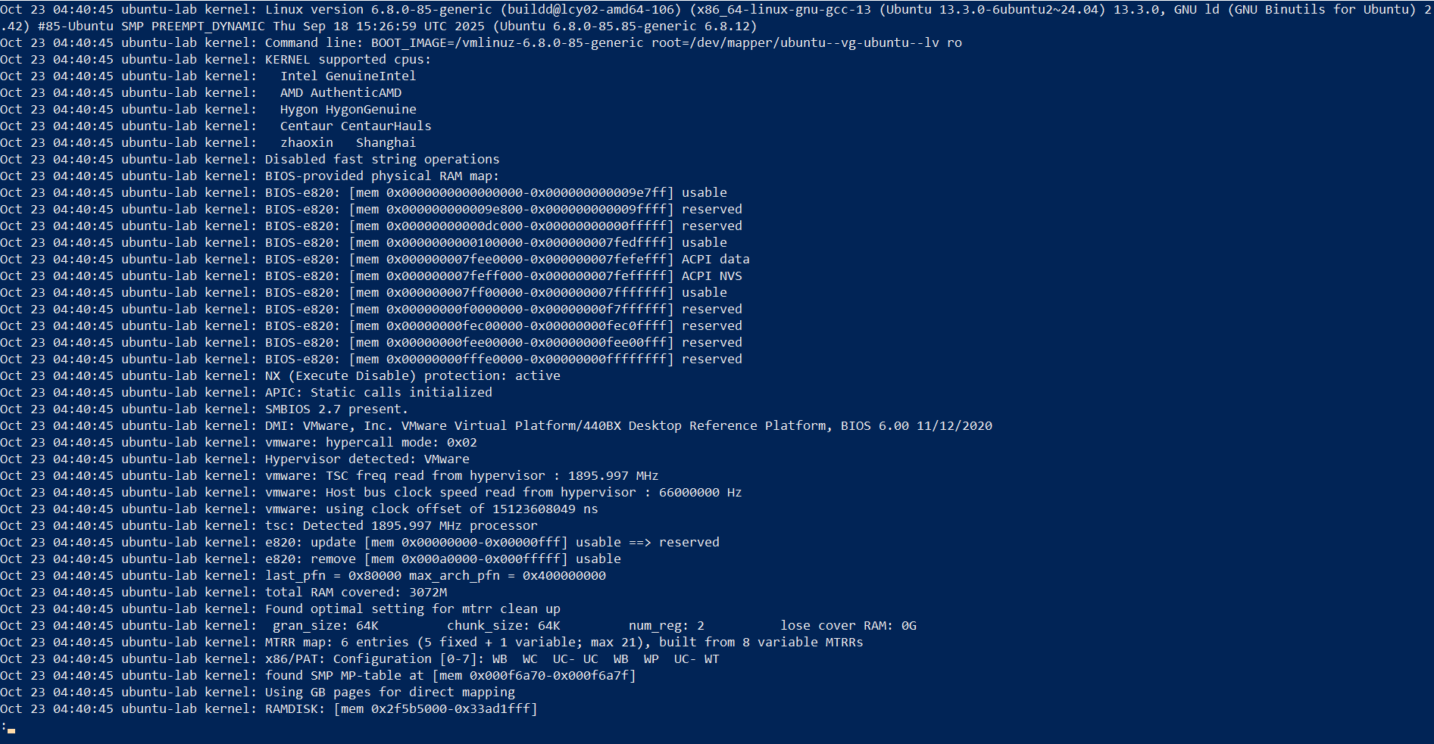
sudo journalctl -u systemd | grep -i error > ~/journal_errors.txt
  - Viewed and filtered logs directly from systemd journal as an alternative to /var/log/syslog.

Task 10: Bash Script: setup.sh (Variables, Command Substitution, File/Dir Checks, Permissions)
Goal:
Create and run a Bash script named setup.sh using vim, adding code incrementally step-by-step. Each step was edited, saved, executed, and verified with screenshots of the vim editor and terminal output.

- Add Bash Shebang
Code added:
#!/bin/bash
- Opened vim: vim setup.sh
- Inserted the shebang line, saved and quit (:wq).
- Made the script executable and ran it:
chmod +x setup.sh
./setup.sh
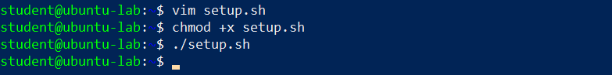
- Define and Display a Variable

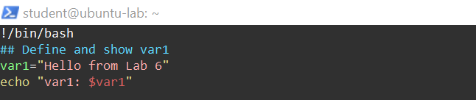
- Edited with vim, appended the code, saved, and executed:
./setup.sh
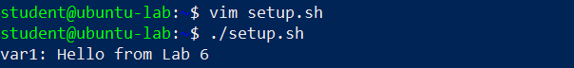
- Command Substitution: Save and Display ls -l

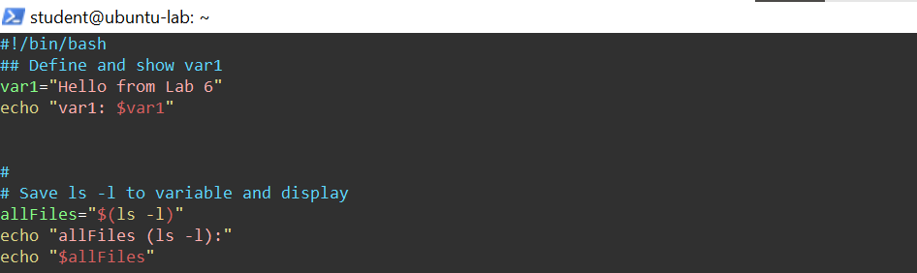
- Appended in vim and executed the script again:
./setup.sh
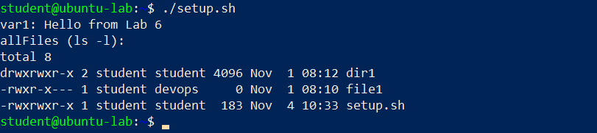
- Directory Check and Creation

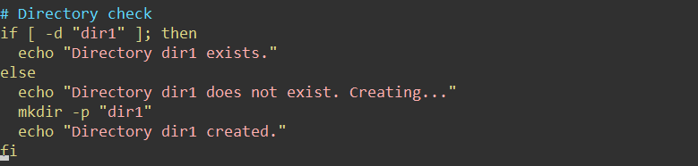
- Appended in vim and ran:
./setup.sh
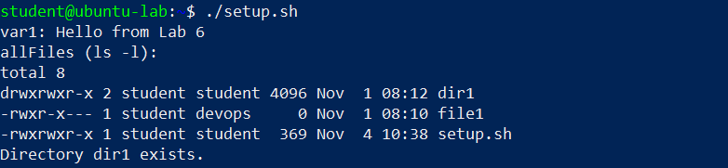

- File Check and Creation

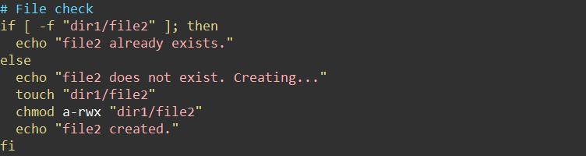
- Appended in vim and executed:
./setup.sh
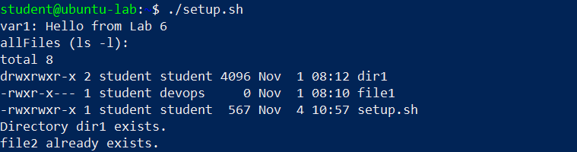
- Permission Check and Adjustment

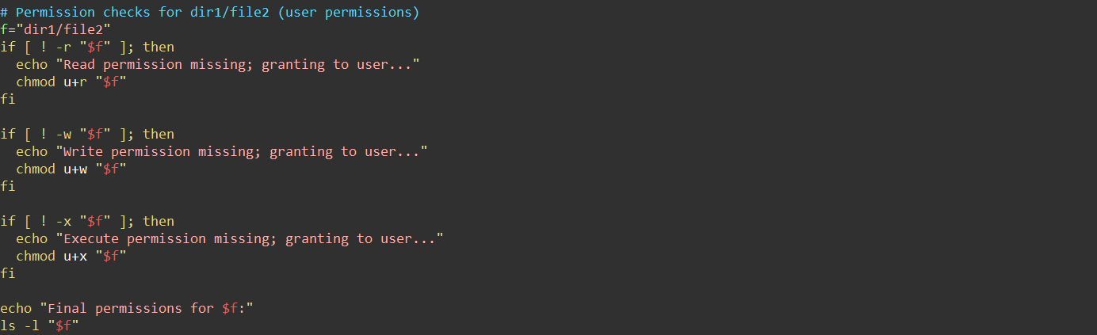
- Appended this section in vim and ran:
./setup.sh
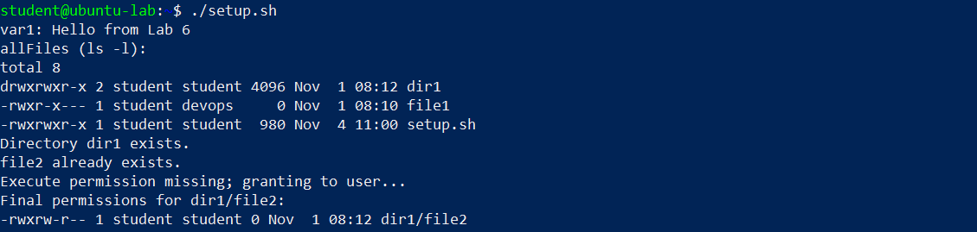

Task 11: Script setup.sh – Argument Comparisons and String Checks
Goal:
Learn numeric and string comparison operators in Bash by adding one if-test at a time and running the script with example arguments.
Each step includes:
- Editing setup.sh in vim (show buffer screenshot)
- Saving and running the script with test arguments (show output screenshot)

  - Shebang, Variable Setup

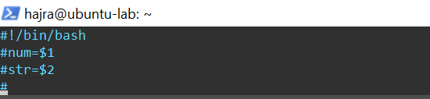
Commands:
chmod +x setup.sh
./setup.sh 10 Student
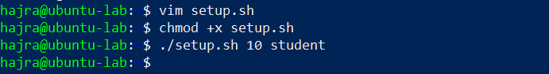
- Numeric Equal ( -eq )

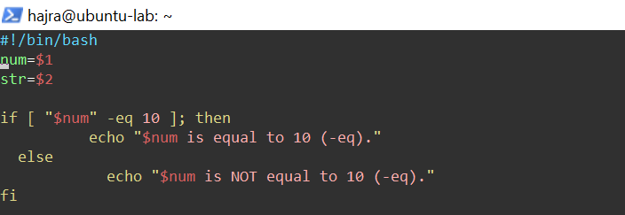
Commands:
./setup.sh 10 Student
./setup.sh 7 Student
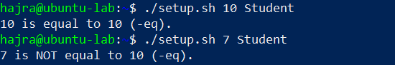
- Numeric Not Equal ( -ne )

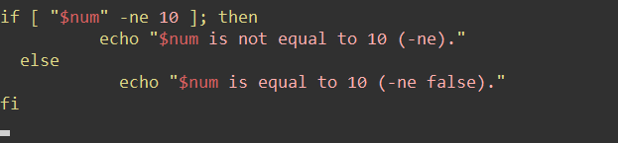
Commands:
./setup.sh 7 Student
./setup.sh 10 Student
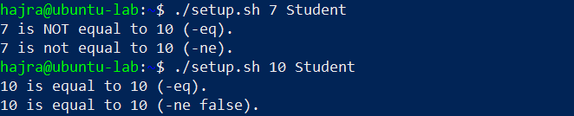
- Greater Than ( -gt )

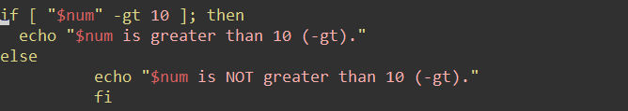
Commands:
./setup.sh 12 Student
./setup.sh 9 Student
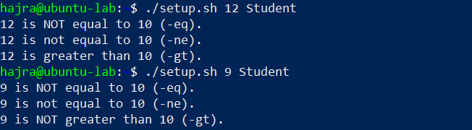
- Less Than ( -lt )

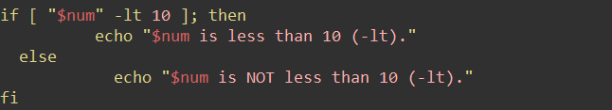
Commands:
./setup.sh 5 Student
./setup.sh 11 Student
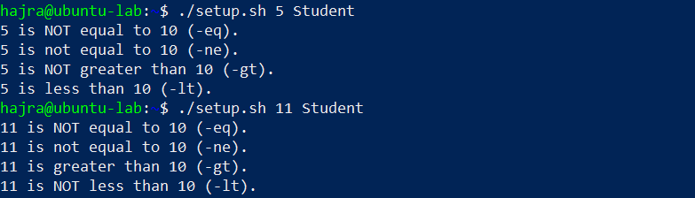
- Greater Than or Equal ( -ge )

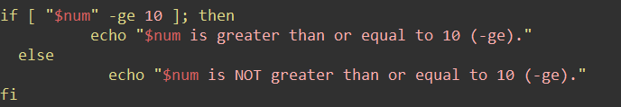
Commands:
./setup.sh 10 Student
./setup.sh 8 Student
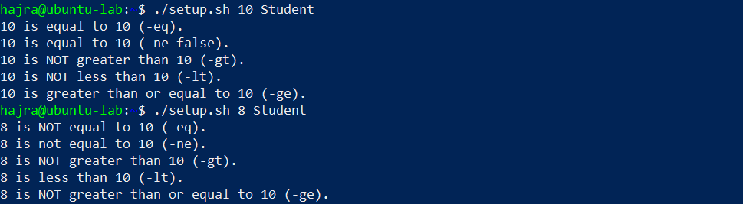
- Less Than or Equal ( -le )

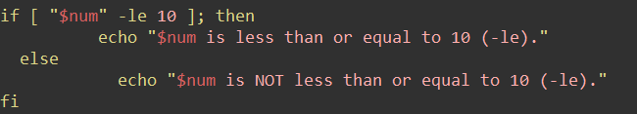
Commands:
./setup.sh 10 Student
./setup.sh 12 Student
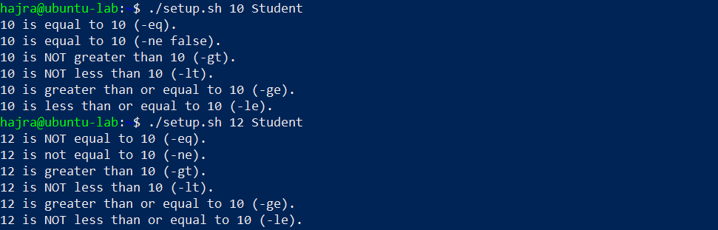
- String Equality ( = )

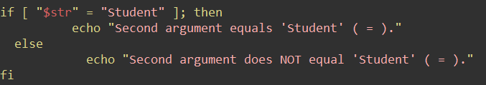
Commands:
./setup.sh 10 Student
./setup.sh 10 Test
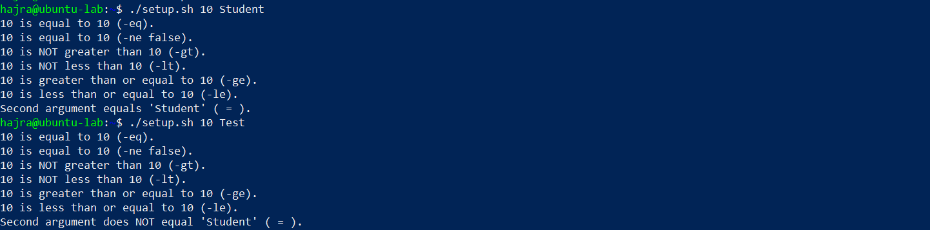
- String Inequality ( != )

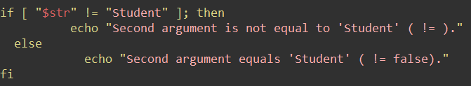
Commands:
./setup.sh 10 Test
./setup.sh 10 Student
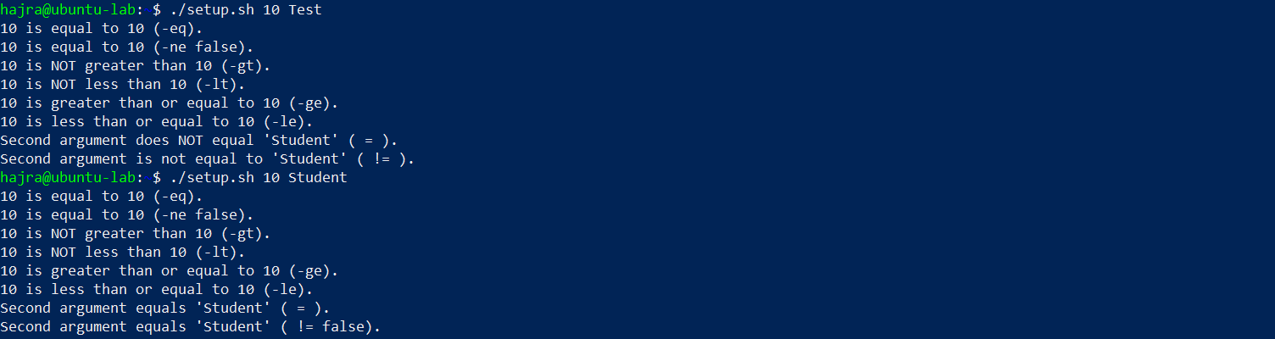
- String Zero-Length ( -z )

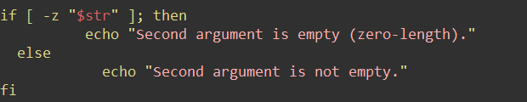
Commands:
./setup.sh 10
./setup.sh 10 Student
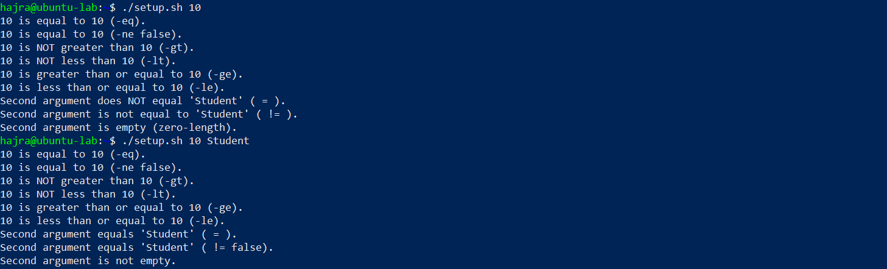

Task 12: Script setup.sh – Print All Arguments with a For Loop
Goal:
Write a Bash script that prints all user-provided command-line arguments using a for loop with $*.

- Shebang and Comment
Code added:
#!/bin/bash
# Script to demonstrate printing all user-entered arguments using $*
Steps:
- Open vim:
vim setup.sh
- Insert the lines above.
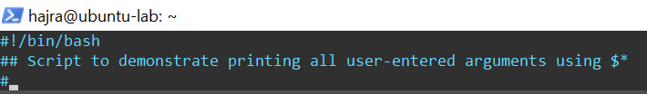
- Save and quit:
:wq
- Run:
./setup.sh
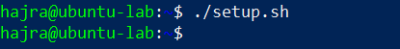
- Append the For Loop Using $*
Steps:
- Reopen the script in vim:
vim setup.sh
- Append the code below the comment.
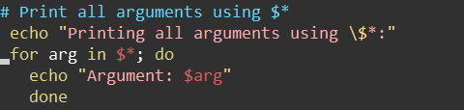
- Save and quit (:wq).
- Make script executable (if not already):
chmod +x setup.sh
- Run the script with sample arguments:
./setup.sh one "two words" three
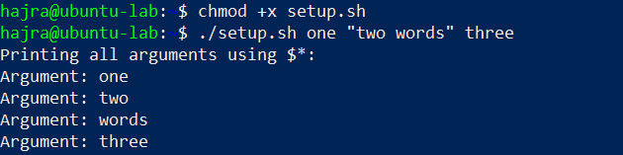

Task 13: Script setup.sh – While Loop Summation and Functions
Goal:
Create a Bash script that:
- Uses an interactive while loop to keep a running total of user-entered numbers until they type q.
- Defines a function sum_two() that performs the same accumulation inside a function.
- Adds another function sum_args() that takes two numeric arguments, adds them, and returns the result.

- Shebang Line
Steps:
- Overwrite any existing setup.sh:
vim setup.sh
- Insert the code line.
- Save and quit:
:wq
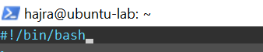
- Make executable and run (no output expected):
chmod +x setup.sh
./setup.sh
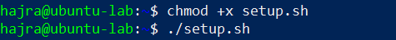
- Interactive While Loop Summation
Steps:
- Re-open script:
vim setup.sh
- Append the above.
- Save and quit (:wq).
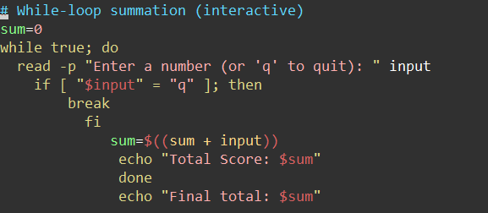
- Run the script and interact:
./setup.sh
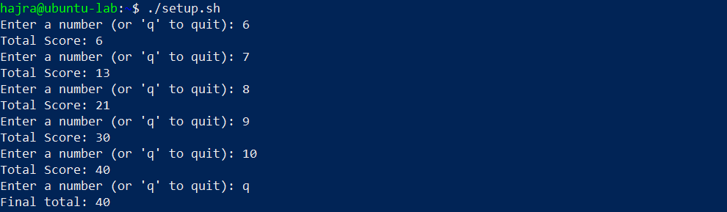
- Function sum_two() (Interactive Loop Inside a Function)
Steps:
- Edit script again and append this function.
- Save and quit (:wq).
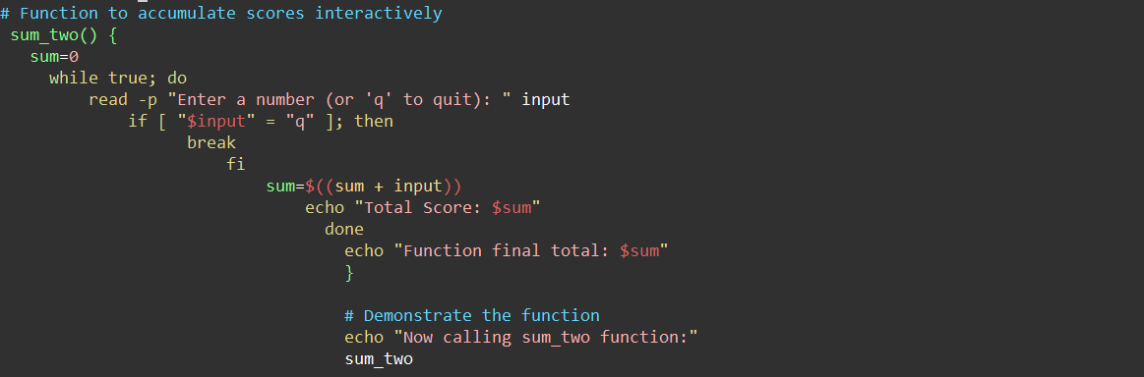
- Run it:
./setup.sh
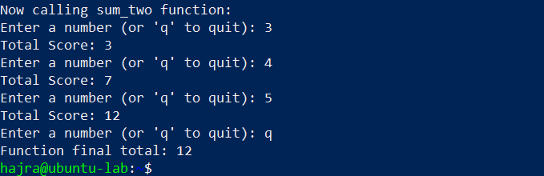
- Function sum_args() (Two Arguments Summation)
Steps:
- Append the code above to setup.sh.
- Save and quit (:wq).
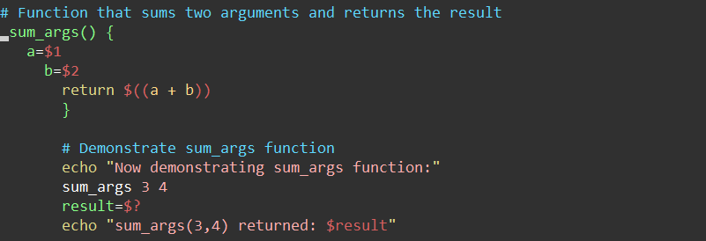
- Run the script:
./setup.sh
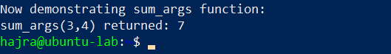

Task 14: Codespaces GUI: Fork Repo, Start GUI, Connect via VNC, Stop GUI
Goal:
Fork a GitHub repository, open it in Codespaces, run the GUI start script, connect via the forwarded port (6080) using vnc.html, and stop the GUI.

- Fork the repository to your GitHub account
  - Open the repo URL in your browser.
https://github.com/WaqasSaleem97/UbuntuMachine
  - Click Fork (top-right) and fork to your account.
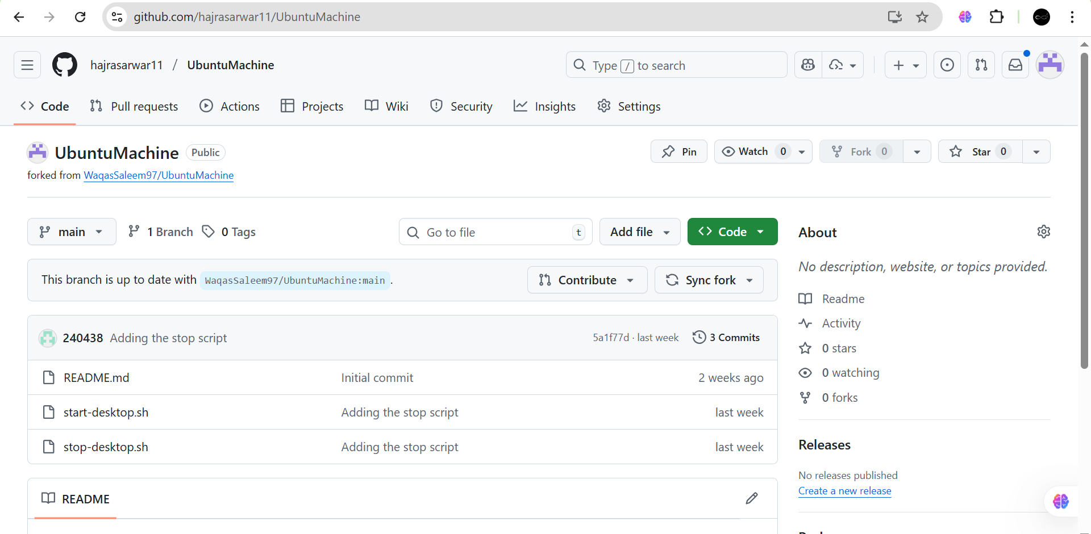
- Open a Codespace on your fork
  - Click Code → Open with Codespaces → Create codespace.
  - Wait for Codespace initialization.
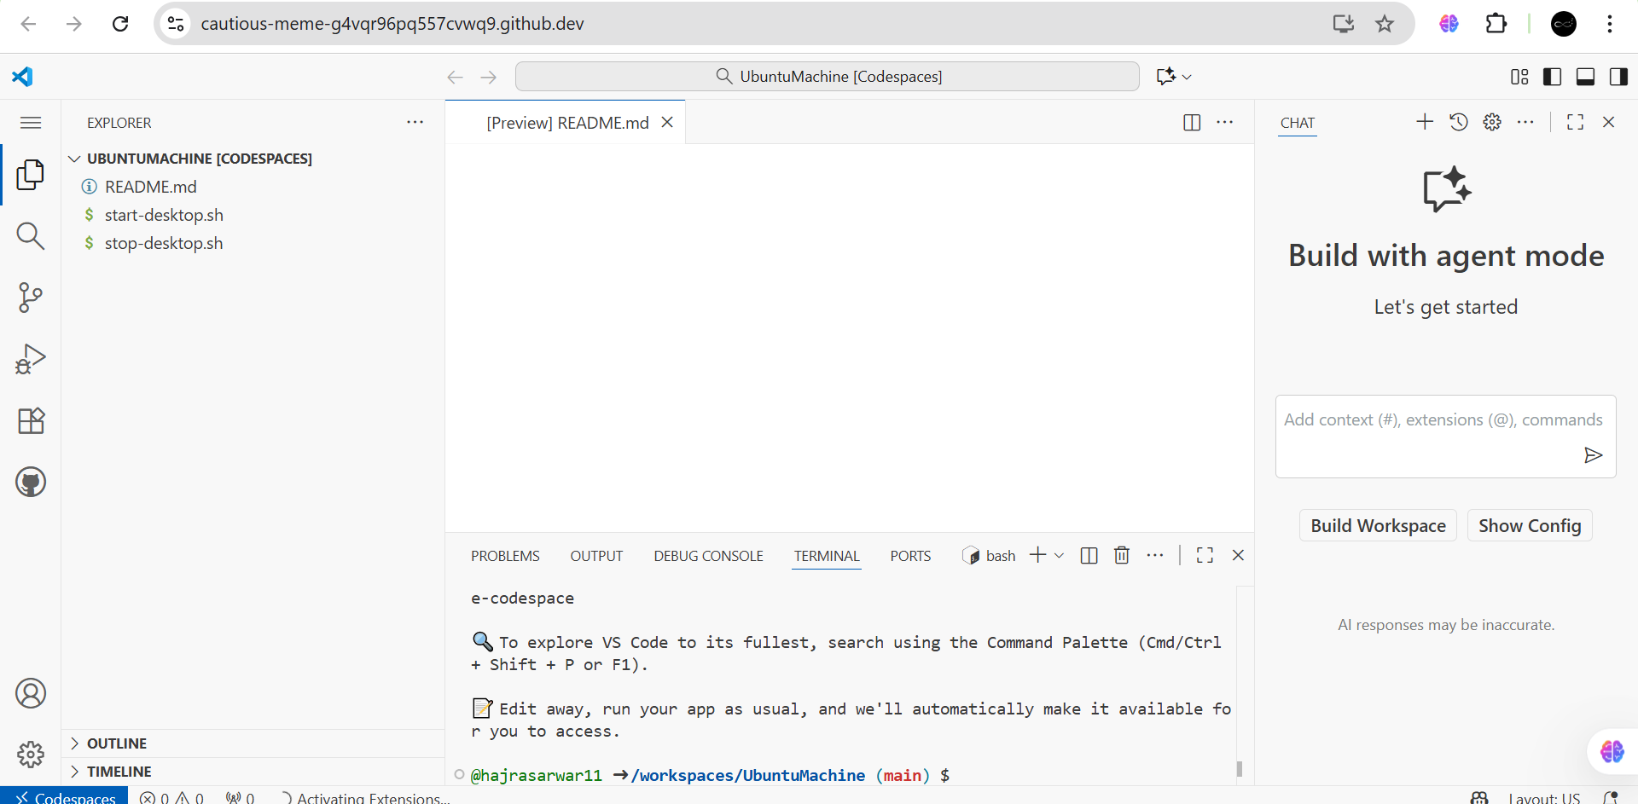
- Verify start/stop scripts exist and are executable
ls -l start-desktop.sh stop-desktop.sh
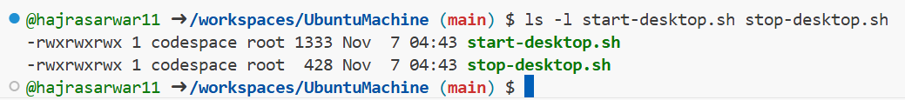
- Run the start script to launch the GUI
./start-desktop.sh
  - Capture terminal output showing successful start.
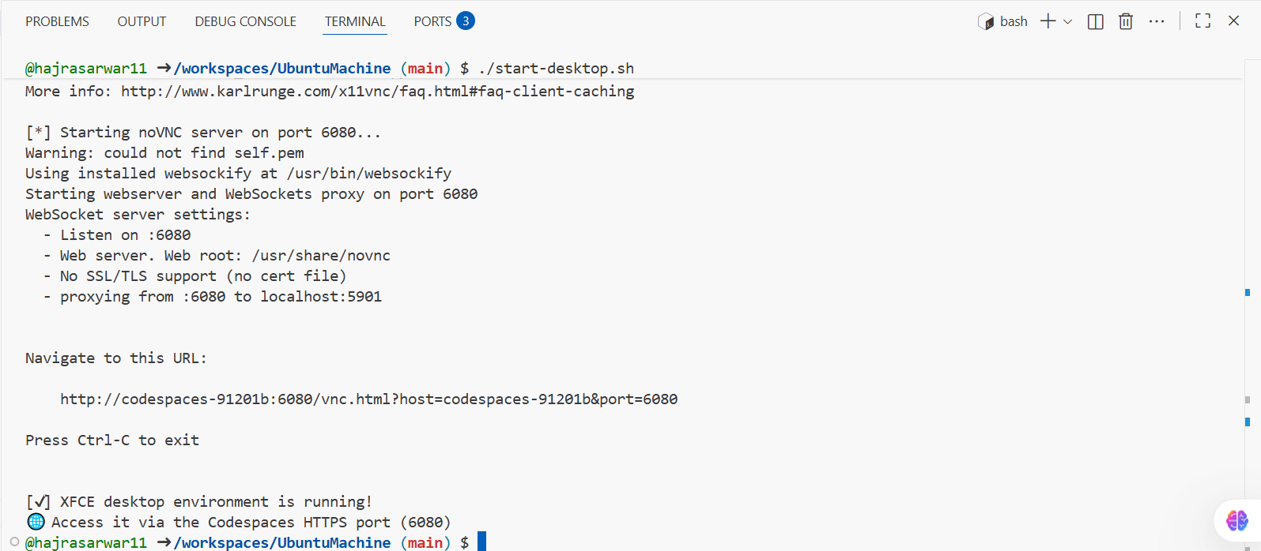
- Verify forwarded ports in Codespaces (Ports view)
  - Open Ports panel and confirm port 6080 is forwarded.
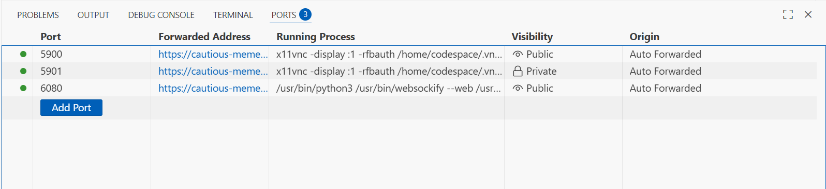
- Connect to the VNC HTML page
  - Open the forwarded port 6080 in the browser or Codespaces preview.

  - Click vnc.html.
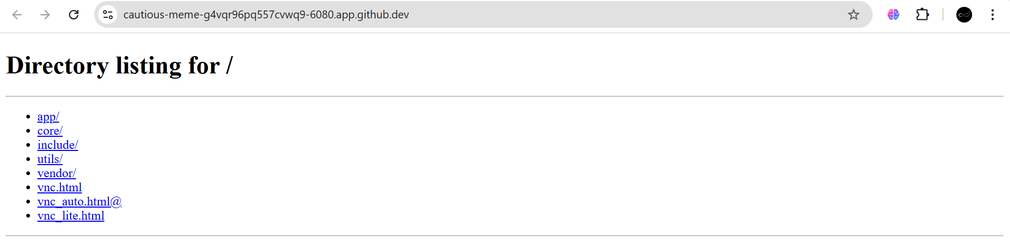
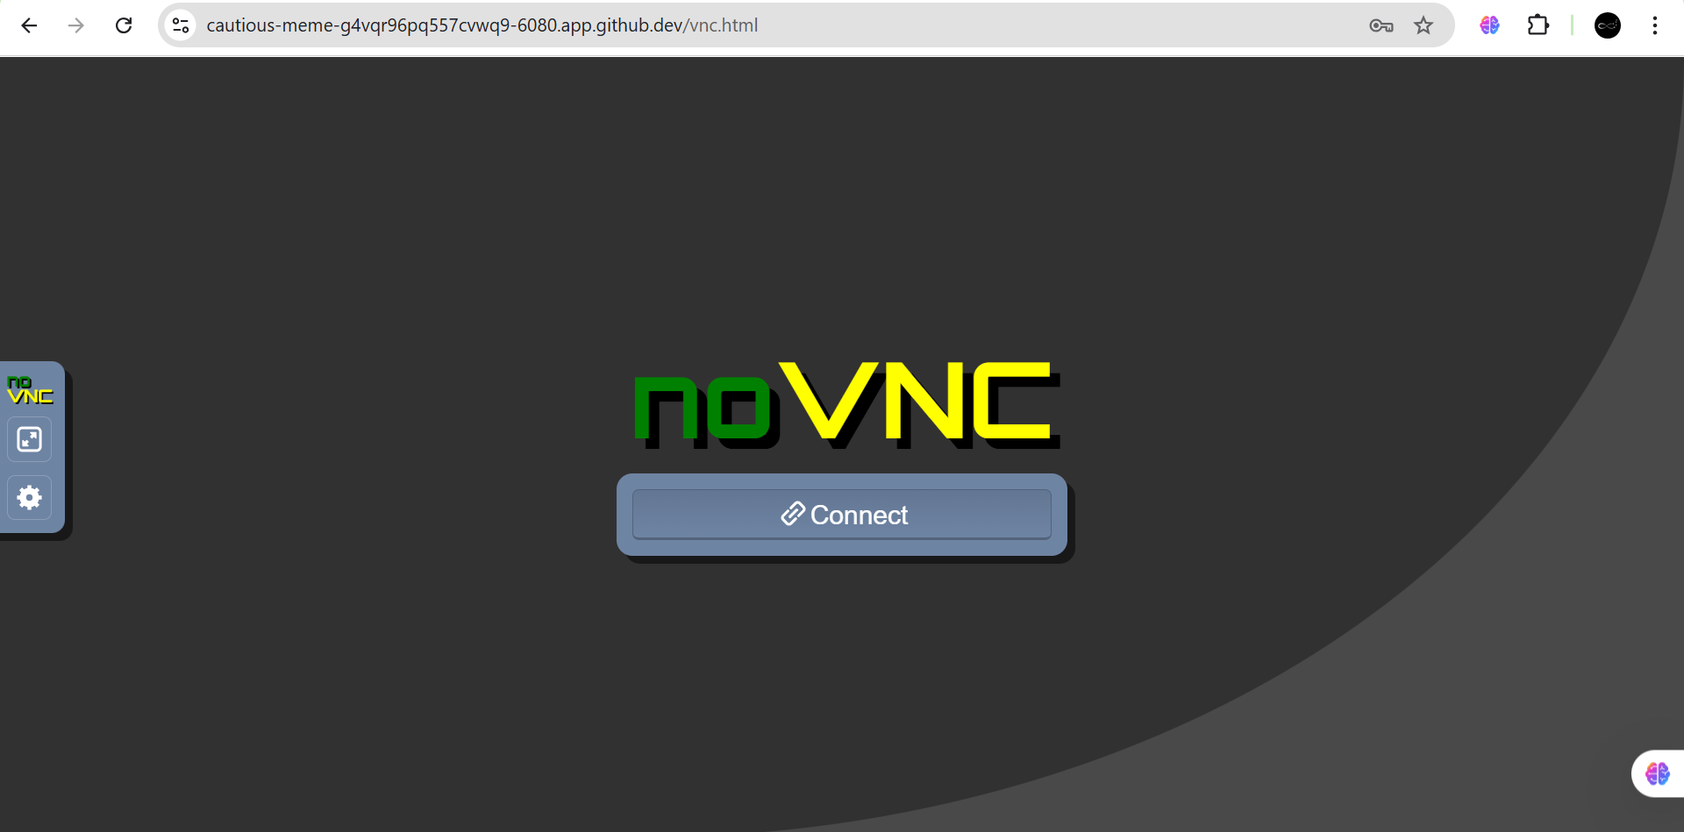
  - Enter password: codespace (do not show typed password).
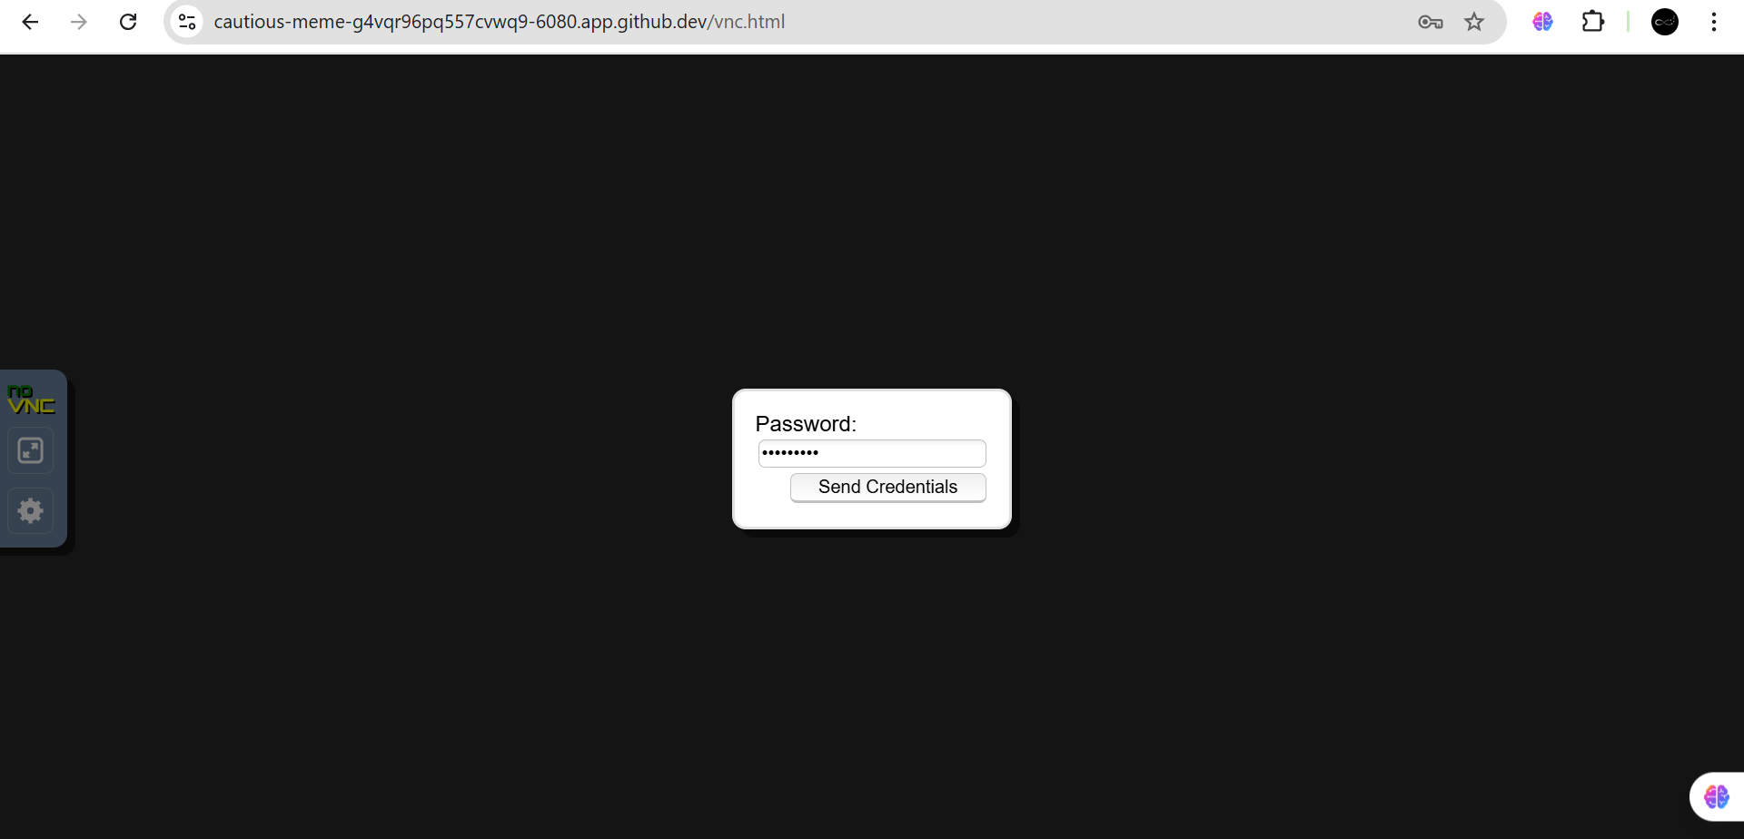
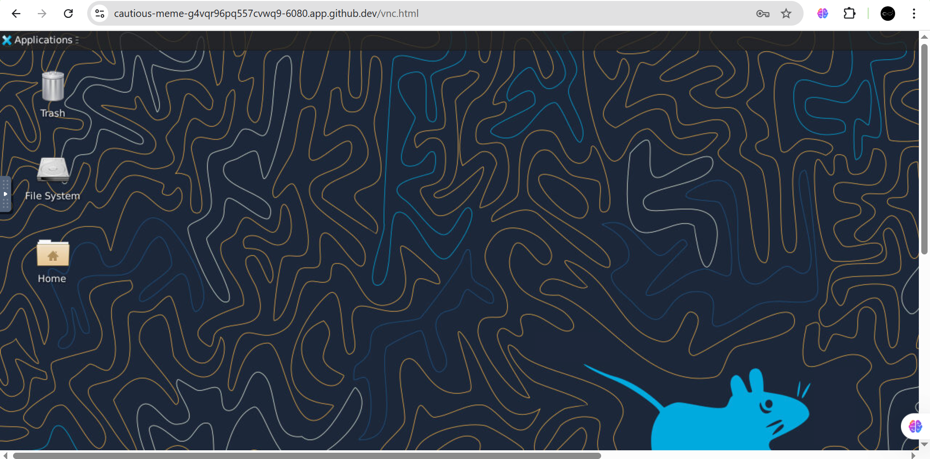
- Stop the GUI
./stop-desktop.sh

  - Capture terminal output showing GUI stop/cleanup.
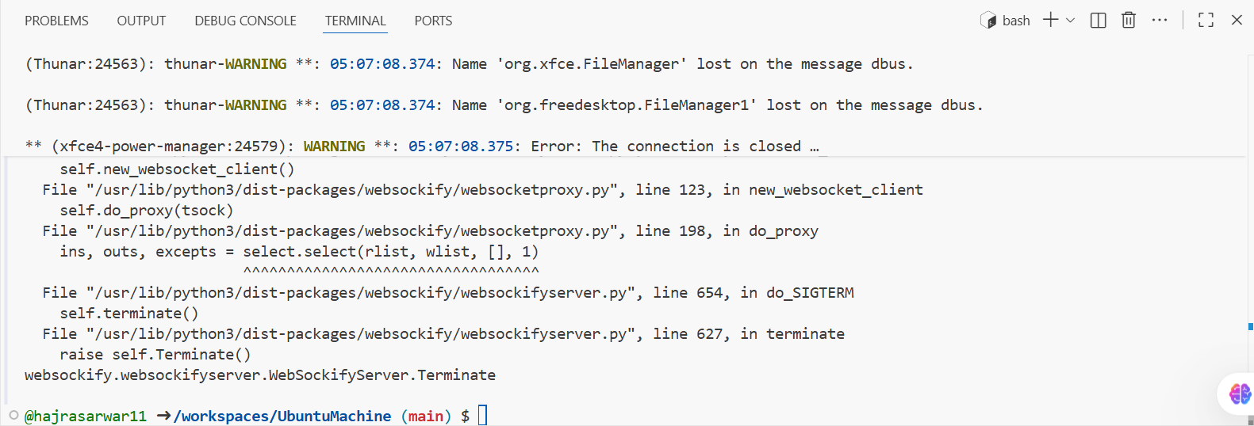

Exam Evaluation Questions

1. Group Management and Membership
Scenario: Create groups and manage a user’s primary and supplementary group memberships.
- Create groups g1, g2, and g3
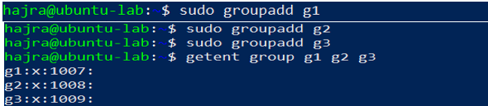
- Change examuser’s primary group and add supplementary groups
  - Primary: g3
  - Supplementary: g1, g2
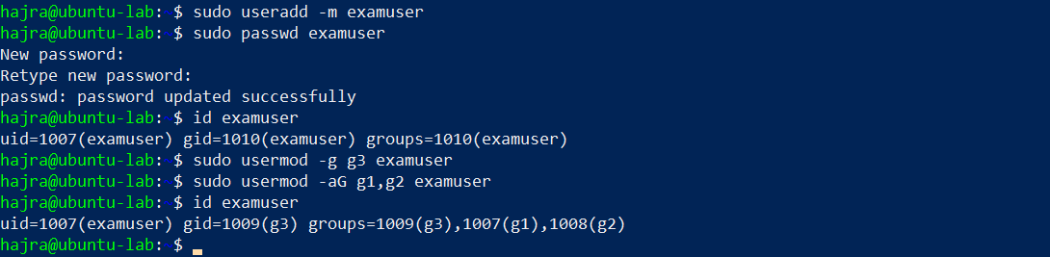
- Verify group changes
  - Show id examuser and relevant /etc/group lines
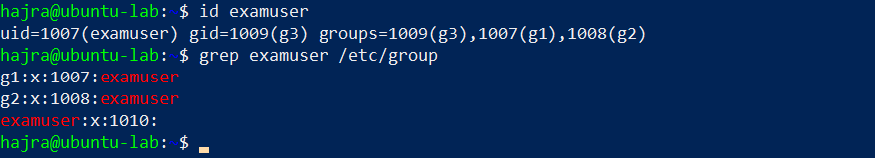

2. Ownership and Permission Tasks
Scenario: Demonstrate ownership changes and apply symbolic and numeric permission changes.
- Create file and change ownership
mkdir -p workspace
touch workspace/secret.txt
chown examuser workspace/secret.txt
chgrp g1 workspace/secret.txt
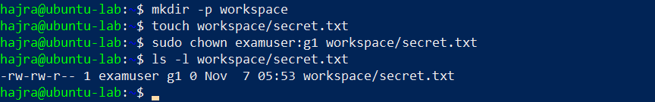
- Remove group/other permissions
  - Symbolic: chmod go-rwx workspace/secret.txt
  - Numeric: chmod 700 workspace/secret.txt
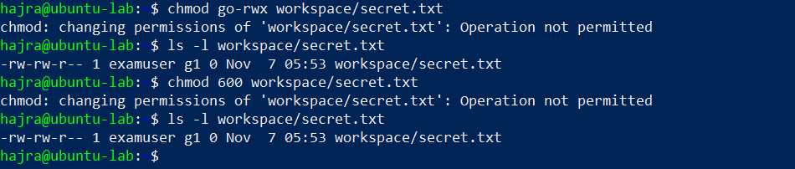
- Show final permissions
ls -l workspace/secret.txt

3. Pipes, Grep, and Redirection Practice
Scenario: Filter system logs and save results using redirection and piping.
- Grep for “error” or “fail” and show first 20 lines
grep -E 'error|fail' /var/log/syslog | head -n 20
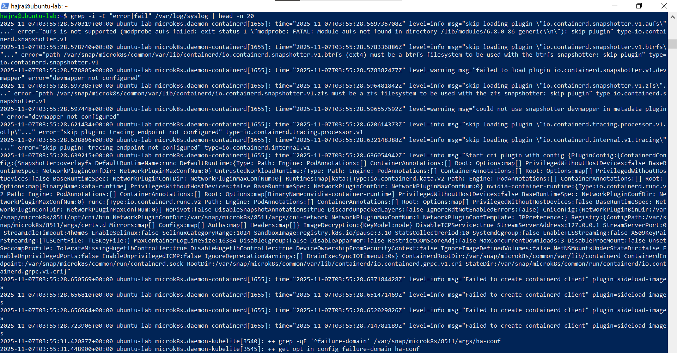
- Save filtered results to a file
grep -E 'error|fail' /var/log/syslog > ~/logs/errors.txt
grep -E 'warning|fail' /var/log/syslog >> ~/logs/errors.txt
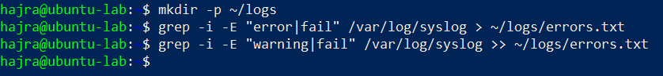
- View the saved file using a pager
less ~/logs/errors.txt
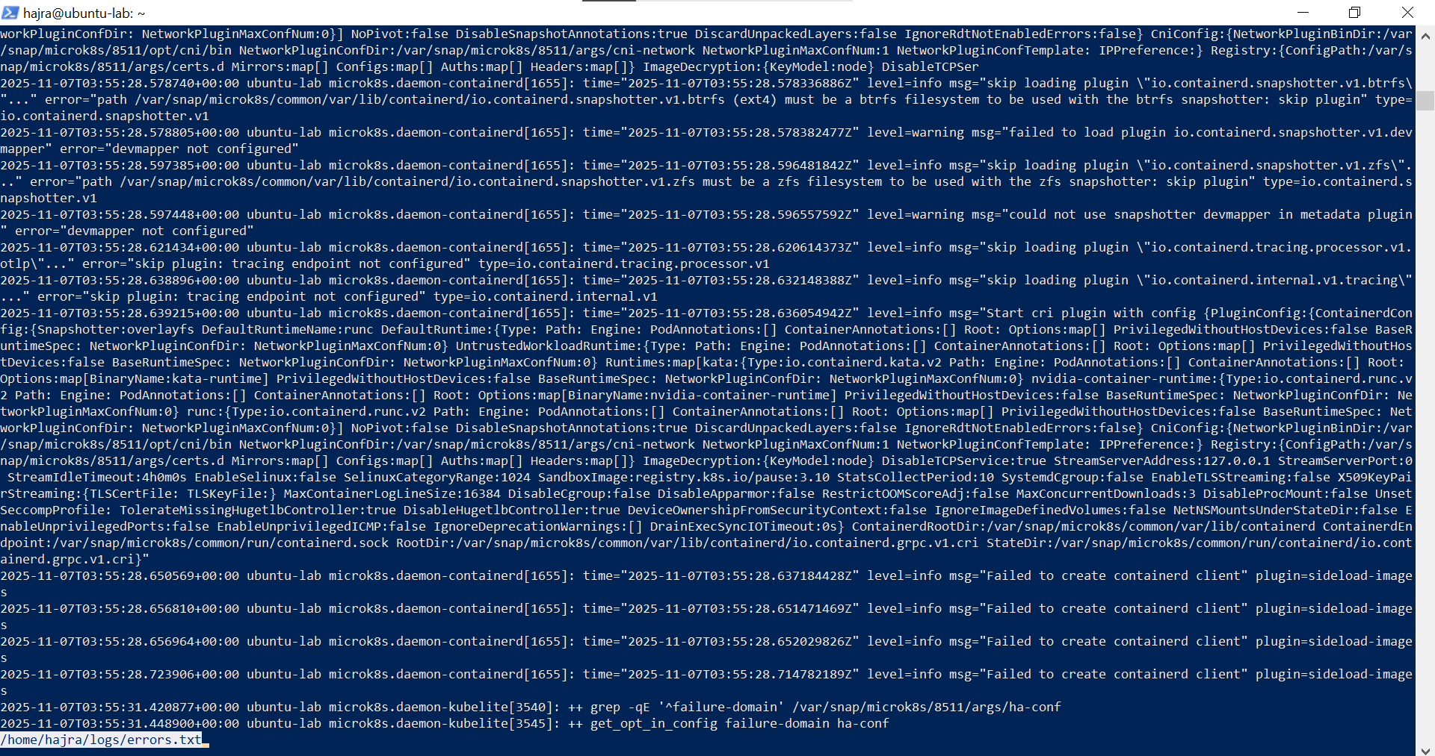

4. Script: Variables, Command Substitution, File & Dir Checks
Scenario: Build and run a script incrementally demonstrating variables, command substitution, and filesystem checks.
- Create setup.sh with shebang and variable var1
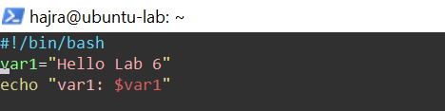
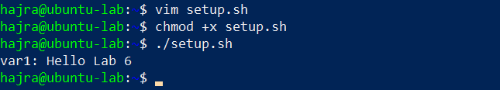
- Append command substitution storing ls -l output
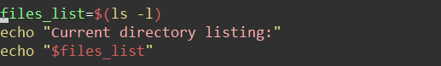
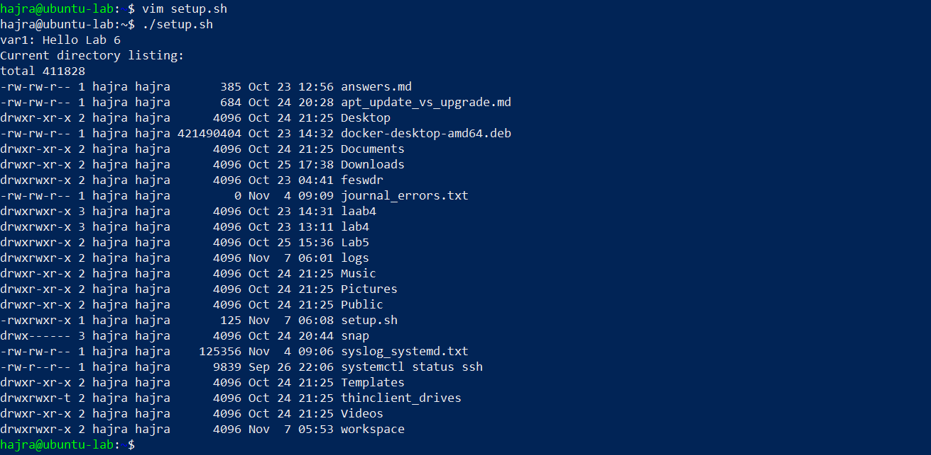
- Append directory/file checks for dir1 and dir1/file2
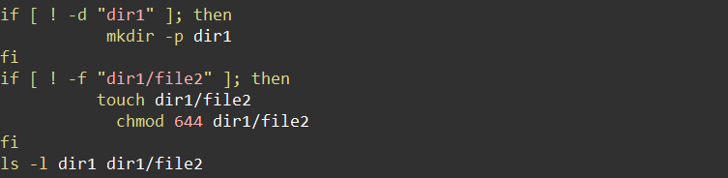
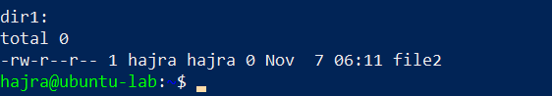

5. Script: Comparisons and String Tests
Scenario: Incrementally add numeric and string comparison tests and show both true/false cases.
- Overwrite setup.sh to set num=$1 and str=$2; add -eq test
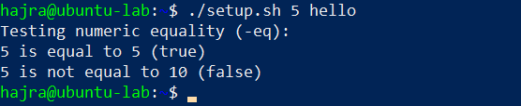
- Append numeric tests: -ne, -gt, -lt, -ge, -l
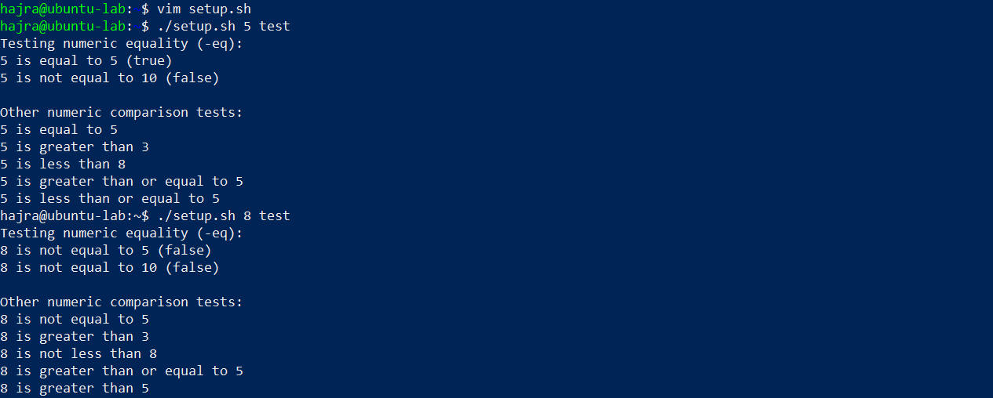
- Append string tests: equality (=), inequality (!=), zero-length (-z)
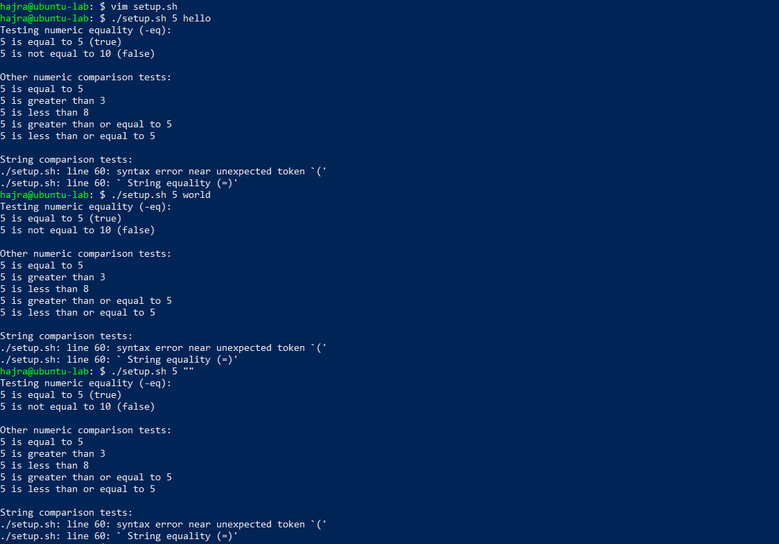

6. Script: For Loop and Argument Handling
Scenario: Print all provided arguments and demonstrate correct handling of quoted multi-word arguments.
- Create/overwrite setup.sh and print each argument using a for loop
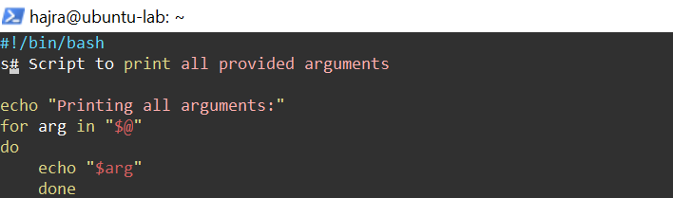
- Run script with single and quoted multi-word arguments
./setup.sh one "two words" three
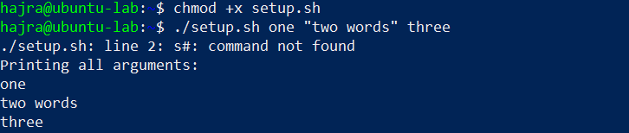

7. Script: While Loop Summation and Functions
Scenario: Implement an interactive summation function and a function returning a numeric result.
- Interactive while-loop that accumulates numbers until q
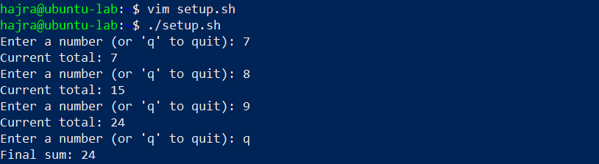
- Function that sums two numeric arguments and demonstrates capturing the result
